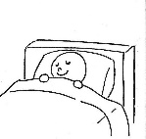
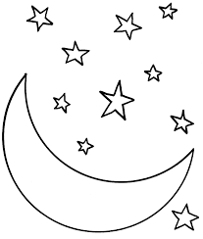
Sleep Audit
It is important to set up ideal conditions to help you sleep. The following have been proven to aid sleep. Rate honestly how often you do each one.
I go to bed at a similar time most days
All / most of the time | Quite often | Half the time | Not that often | Never
I reduce my energetic activity at least 1-2 hours before bed
All / most of the time | Quite often | Half the time | Not that often | Never
I eat my last meal/snack at least 2 hours before bed
All / most of the time | Quite often | Half the time | Not that often | Never
I sleep in the dark (or with a small night light)
All / most of the time | Quite often | Half the time | Not that often | Never
I avoid using screens 1 hour before bed
All / most of the time | Quite often | Half the time | Not that often | Never
I avoid caffeine before bed (ideally 6 hours before)
All / most of the time | Quite often | Half the time | Not that often | Never
My room is generally a cool temperature
All / most of the time | Quite often | Half the time | Not that often | Never
My room is generally quiet at night
All / most of the time | Quite often | Half the time | Not that often | Never
My room is clean
All / most of the time | Quite often | Half the time | Not that often | Never
I wake up at a similar time most days
All / most of the time | Quite often | Half the time | Not that often | Never
I dim the lights before I try to sleep
All / most of the time | Quite often | Half the time | Not that often | Never
I read or listen to a book/calming music before I try to sleep
All / most of the time | Quite often | Half the time | Not that often | Never
I feel comfortable in bed (good mattress, favourite toy)
All / most of the time | Quite often | Half the time | Not that often | Never
I avoid looking at a clock at night
All / most of the time | Quite often | Half the time | Not that often | Never
My devices are outside of my bedroom at night
All / most of the time | Quite often | Half the time | Not that often | Never

